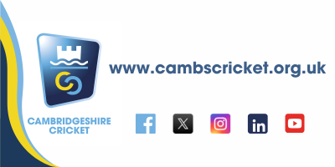

**SAFEGUARDING MATTERS**

**February 2025**

**Ensuring cricket in Cambridgeshire is a**

**welcoming, safe, inclusive and enjoyable sport for young and old.**

**HELLO AND HAPPY NEW YEAR!!**

As we emerge from the winter months and Spring is on the horizon thoughts are turning towards the start of the cricket season. I wanted to get a newsletter out now to share some really important messages so you are all prepared for the coming season.

I have decided to start sending these newsletters to a wider audience than just Club Safeguarding Officers because the responsibility for Safeguarding lies with all, I want the messaging to land with more club and league committee members to enhance understanding so that Club Safeguarding officers aren’t bearing all of the responsibility for embedding a culture of safeguarding in our clubs.

To that end I really need engagement from clubs, I want to hear your views, I want to hear what you are doing at your clubs and I want to come and visit you at your clubs to see the good work you are doing to ensure we have a safe game that our players want to keep playing.

Communicate with me at [safeguarding@cambscricket.org.uk](mailto:safeguarding@cambscricket.org.uk)

**There is some really important content in this newsletter that needs actioning and sharing.**

**I would really appreciate an email in response to acknowledge you have read the contents, please state your role and club in the email.**

This edition:

* Safe Hands workshops dates
* Safeguarding for Specialist Roles (SSR) training changes
* Changes to the DBS process for volunteers
* New process for under 11s in open age cricket
* Low level concerns reporting
* Developing a Listening culture

**Safe Hands Workshops dates**

We have three dates available for Safe Hands Workshops which are a mandatory requirement every three years for Club Safeguarding officers. The workshops are a face to face 3 hour session with myself that cover the importance of safeguarding in our game and the role of the club safeguarding officer. The sessions are interactive and also a good opportunity to meet with and learn from peers in the same role. Spaces are filling up fast so be sure to get booked on by using the link on our website:

[Safeguarding training | Cambridgeshire Cricket Limited](https://www.cambscricket.org.uk/safeguarding-training/)

Dates are 25th Feb at Over, 12th March at Sawston & 1st May at Over all 6.15 to 9.30pm.

**Safeguarding for Specialist Roles (SSR) training changes**

Online SSR training is one of the pre-requisites for a Club Safeguarding Officer along with attending a Safe Hands workshop (as above) and a DBS check.

The Cricket Regulator are currently developing a new online course to replace SSR which will be titled Safeguarding Level 2 (SGL2) and should be available by the end of February. If your SSR training has expired or is due to soon it is suggested that you wait for the new course to be available so that you can have the most up to date information.

Please note there is no need to do the SGL2 if your SSR is still in date, SGL2 will be the new course you do as SSR expires.

**Changes to the DBS renewal process for volunteers in cricket**

*****Please share with all of your club volunteers who need an ECB DBS*****

The Disclosure and Barring Service has initiated a change in the process for updating certification for volunteers. The procedure required an individual (volunteer) to confirm annually to the ECB that they are continuing in their role which facilitates the automatic renewal of their DBS certificate. A customer would receive a separate notification from the Disclosure and Barring Service indicating to them that they are not required to take any action to update their certificate and their subscription will continue.

The Disclosure and Barring Service has now modified its user agreement, mandating that all individuals log into their update service account to renew their subscription on an annual basis. Should this not be actioned, their account will lapse, resulting in a failed check for the ECB, and the individual will be required to apply for a new DBS certificate as the DBS does not permit the reinstatement of Update Service subscriptions after lapsing.

**What does an individual need to do?**

1. **Action the communication from the ECB once received 30 days prior to renewal:**

**(Give consent and confirm their Role/Club/Contact details).**

Email from [**dbs@ecb.disclosures.co.uk**](mailto:dbs@ecb.disclosures.co.uk)

Titled: **ECB DBS Expiry - Important Message - Action required**

1. **Action the communication from the DBS Update service received 30 days prior to renewal: (log in and renew subscription)**

Email from [**donotreply@dbs.gov.uk**](mailto:donotreply@dbs.gov.uk)

Titled: **FYI: Action required to renew your Update Service subscription**

**NEW PROCESS FOR 11 YEAR OLDS PLAYING OPEN AGE CRICKET**

There is a new process in place that must be followed in order for 11 year olds (school Year 7) who are on our talent pathway to be able to play in open age cricket. The document embedded below explains the process and contains the form that needs to be completed by parent and club safeguarding officer before being forwarded to Cambridgeshire Cricket for the County Age Group Pathway Lead and County Safeguarding Officer to sign off.



The key thing to note here is this is not just about cricketing ability but also whether the individual is ‘ready’ to play open age cricket.

**Low level concerns (LLC) reporting**

The Cricket Regulator is encouraging low-level reporting across our game to ensure poor practice and unacceptable behaviour is recorded and addressed at an early stage. Low level does not mean it is insignificant just that it doesn’t meet the threshold for a referral to the Cricket Regulator.

The document embedded below explains on a page what a Low Level Concern is, please read it and acknowledge that you have by responding to me at [safeguarding@cambscricket.org.uk](mailto:safeguarding@cambscricket.org.uk)

Going forward any reports you wish to make of a LLC should be made to me at the same email address.



**Developing a Listening culture**

In my previous newsletter at the end of last season I sent a plea for help from all of you to share good ideas you have at your clubs for listening to children. I had a pretty disappointing response to be honest so am asking again for any examples of good stuff you are doing to show how you listen to your young players.

The idea of listening to children and acting upon their feedback is that it supports safeguarding in that children who feel they are listened to regarding smaller issues are more likely to talk to us about the ‘bigger’ issues when they need to.

As an example here at Cambridgeshire Cricket over the winter we have introduced QR code keyrings across our Talent pathways for all of our young players. Every player has a keyring with a QR code on (pictured below) that they can scan on their smartphones/tablet devices to take them to a feedback form to share their feedback with us.

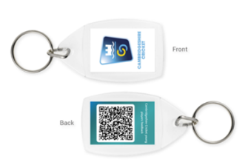

**THANKS FOR READING**

Hopefully you have stayed with me, read everything up to this point and found the updates useful. If you have any questions or feedback then please don’t hesitate to contact me.

I will be in touch again before the season gets under way but in the meantime look forward to hearing from each of you. I will be attending the AGMs for both the Cambs & Hunts Premier League and the CCA League in the coming weeks so may meet some of you at those.

Jamie

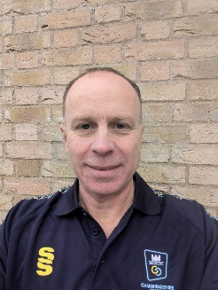

**Jamie Rice**

**Cambridgeshire Cricket County Safeguarding Officer**

[**safeguarding@cambscricket.org.uk**](mailto:safeguarding@cambscricket.org.uk)

**Safeguarding Concerns Number: 07537 830296**

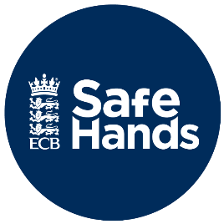

Link to the ECB Safeguarding pages

[England and Wales Cricket Board (ECB) - The Official Website of the ECB](https://www.ecb.co.uk/news/79221/safehands)