

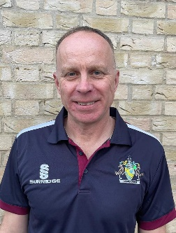

**Jamie Rice**

**Cambridgeshire Cricket County Safeguarding Officer**

[**safeguarding@cambscricket.org.uk**](mailto:safeguarding@cambscricket.org.uk)

**Safeguarding Concerns Number: 07537 830296**

**SAFEGUARDING MATTERS**

**Ensuring cricket in Cambridgeshire is a**

**welcoming, safe, inclusive and enjoyable sport for young and old.**

**Hello!**

So we are now well into the season and have thankfully benefited from some good weather over the past few weeks so should all have seen plenty of cricket recently. As promised I want to try and communicate regularly with all club safeguarding officers without over burdening you with messaging, so I wanted to get another bulletin out to you before the end of the season.

Thanks as always for your time and efforts at your clubs.

This edition

* Online drop in session for Club Safeguarding officers
* Cambridgeshire Grassroots Awards
* Live streaming guidance change
* Whats App age limit changes
* ECB Cricket playing survey
* Listening culture- plea for help (reward available!)

**Online drop in session for Safeguarding Officers**

**Monday 12th August 6pm to 8pm**

As part of my efforts to be accessible whilst also making it easy for you to communicate with me I have arranged an online session over Teams. This is an opportunity to meet myself and my colleague, Neil Liversedge, who is the cricket development officer for volunteers. He leads for us on all things DBS and the Safe Hands Management System so if you have a question around those then make sure you dial in.

I appreciate you all have busy lives so myself and Neil will be online for the full two hours between 6pm and 8pm on Monday 12th August and I invite you all to dial in (using the link above) at any point convenient to you to say hello, ask any questions you may have around safeguarding and also give us any suggestions as to how we can better support you in your roles.

[**Join the meeting now**](https://teams.microsoft.com/l/meetup-join/19%3ameeting_ZDVjZjBkNjAtMmFmNC00ZWZkLTgwZTAtYjEwM2NmNDMzMjYy%40thread.v2/0?context=%7b%22Tid%22%3a%22443a3f52-da32-4f80-828a-cc6b12e9a11b%22%2c%22Oid%22%3a%22a43ec8e1-49b0-47bb-89d4-2eb023ee3198%22%7d)

We also plan to hold an ‘in person’ event next year where Safeguarding officers can come together at a venue to hear the latest ECB and Cricket regulator updates, share ideas and discuss challenges. Look out for communication around this towards the end of the season, I will be asking for suggestions regarding content and also the best time to run the event to get the best attendance from as many of you as possible.

**Cambridgeshire Cricket "The Cricket Collective" Grassroots Awards 2024**

Deadline Sunday 18th August

Within Cambridgeshire we have some great clubs, leagues and associations that make cricket work. Regardless of club size, each club in the County have reasons to be proud, this is because of the volunteers within their clubs doing something special to make cricket happen.   
The volunteers do not come in one package, they are a varied bunch, not all young, not all old. Some are players, some are coaches, some are match officials, some devote their time outside, some inside. Some are seen doing their stuff in spring and summer, whereas others do their hard work in the autumn and winter months. Some have been doing their thing for years, some are new to your club or new to volunteering.   
If you are a volunteer in cricket you are part of "The Cricket Collective!" and we thank you and the Grassroots Cricket Awards are about recognising and rewarding our volunteers that make cricket a game for everyone!  
There are 14 categories (including one for Safeguarding) and we are sure every club must have someone suitable for at least 3 categories and we want to make the 2024 awards the biggest ever, please use the link below to nominate a deserving volunteer.

[https://forms.office.com/e/dMVr8R95ak](https://forms.office.com/e/dMVr8R95ak?fbclid=IwZXh0bgNhZW0CMTAAAR2IWqQc-qVkW_TeKKIw5ceTr0hcDbw1HmVCgkc1BiBj3vgTkiCqZB0OD28_aem_1tVQzkOfLeZT_pfrqqVOig)

**Live streaming guidance change**

Please note that the guidance on photo, video and live streaming is in the process of being amended to reflect ECB safeguarding policies. The main change for you to be aware of is the increase in age from 16 years to 18 years. Consent to live streaming is required from a parent/carer of any player U18 (as opposed to U16 as per previous guidance.)

An updated version of the full policy will be available in the Safeguarding Kit Bag shortly.

**Whats App age limit change**

Meta have recently changed the age limit for users of Whats App to just 13 years, the ECBs messaging around this remains clear as follows:

*“However, this does mean that the safeguarding precautions/standards that we set remain firm, and we should all be extra vigilant and ensure the guidance is clear that no contact occurs directly between an adult and a child on this or any other social media platform.”*

I have embedded below a guidance document around Whats App for info and have access to another, if anyone would like to receive a copy then please email me.

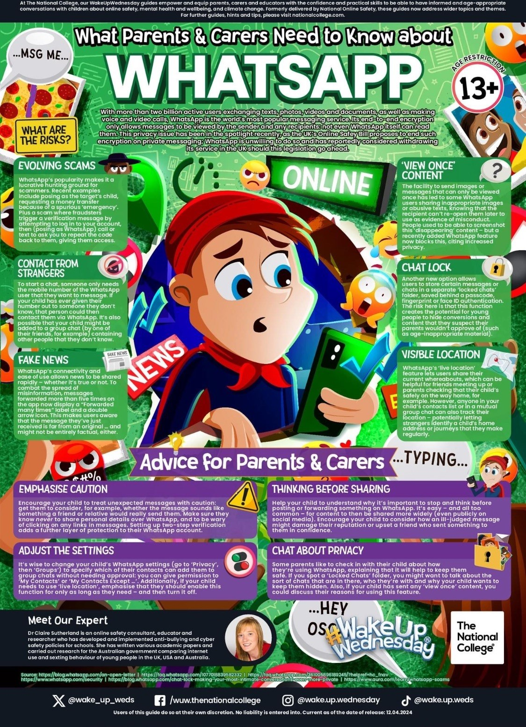

**ECB Cricket playing survey**

Deadline Monday 12th August 2024

Can I ask you all to share with your club members the below link for the ECB’s Cricket Playing Survey.

[Cricket Playing Survey 2024 (tell-us-what-you-think.com)](https://ecb.tell-us-what-you-think.com/s3/CPS24)

It provides a chance for recreational players and volunteers to have their say and influence the future of cricket at grassroots level. Over the past few years, this feedback has helped shape the game.  
Sharing your opinion on how the sport is run today, and how you think cricket could develop and improve, provides valuable insight to the ECB, counties and leagues across England and Wales, to turn your ideas into actions.

**Listening culture- help needed**

As a cricket board Cambridgeshire Cricket have a number of standards set by the ECB that we have to work towards, one of those under Safeguarding is titled ‘Listening’ and involves us demonstrating how we listen to children, young people and adults throughout all aspects of cricket.

Im keen to hear your views on this and would love to know of any ideas that you may have to achieve this standard. Are there things you do at your clubs that you could share? Anything you think we as a board could do to show we are listening to our players and volunteers in the county?

Any good ideas that you can suggest may earn a reward so please get thinking.

**A plea from me**

I want to repeat the plea in my previous bulletin because I had a limited response from you all. I am here to support you as volunteers so I want to meet as many of you as possible at your clubs to witness first hand the good work that you are all doing. Over the past couple of months I have attended junior training at Therfield (Royston CC) on a Sunday morning and also a junior match at Cottenham, at both of these I have been able to have a good chat with club officials to hear about their work and plans for their club in the future, there is some great work going on out there (not just in terms of safeguarding) and as a club cricketer myself I love to come and watch and talk cricket.

Please invite me to your junior training sessions, matches or any festival/competition that you are running so I can come along.

I hope you have enjoyed reading this bulletin and found it useful, please let me know if you have any feedback or suggestions for future content. Thanks for reading and have a good season!

Jamie



Link to the ECB Safeguarding pages

[England and Wales Cricket Board (ECB) - The Official Website of the ECB](https://www.ecb.co.uk/news/79221/safehands)